**SOLUTION DESIGN DOCUMENT**

**Finance Policies Agent**

Version v1.0

Revision History

|  |  |  |  |
| --- | --- | --- | --- |
| Date | Revision | Author | Description |
| 28-01-2025 | V1.0 | Gumma Aruna Kumari | SDD |
|  |  |  |  |
|  |  |  |  |

Table of Contents

Revision History 1

Distribution 3

1 Introduction 4

1.1 Overview 4

1.1.1 Business Requirement 4

1.1.2 Process Description 4

1.1.3 Features of Bot 4

1.1.4 Prerequisite 4

1.2 Proposed Solution 4

1.3 Scope 4

2 Contacts 4

3 Quick Facts 5

3.1 Idea Assessment 5

3.2 Project 5

4 Architecture 6

4.1 Overview 6

4.2 Flow Diagram 6

4.3 Hyper Automation Co-Pilot Diagram Overview 8

5 Solution Components 9

5.1 Create the Co-Pilot using Microsoft Co-Pilot Studio 9

5.2 Train the Created Co-Pilot with the Required Data 10

5.3 Create the Topics in Co-Pilot 11

5.4 Power Automate Flow Integration 13

6 Data 14

6.1 Ticket Management Table: 14

6.2 Resolution Summary Table: 14

6.3 ER Diagram: 15

7 Regulatory Requirements 15

8 Security 15

8.1 Risks and Mitigation 15

8.2 Solution Metrics 15

8.3 License Estimation 16

8.4 Triggers 16

8.5 Business 16

8.6 Technical 16

# Distribution

The information has restricted distribution and viewing within Chanel.

Document Version Control

|  |  |  |  |
| --- | --- | --- | --- |
| Date Issued | Version | Description | Author |
| 28/01/2025 | V1.0 | SDD | Gumma Aruna Kumari |
|  |  |  |  |
|  |  |  |  |

Document Sign-off Requirements (NA)

The following table contains the people required to sign-off and/or review this document and those that require the document for information only.

|  |  |  |
| --- | --- | --- |
| Name | Department | Responsibility |
| Suranjana Chowdhury | Power Platform | Lead |
|  |  |  |
|  |  |  |

# 1 Introduction

## 1.1 Overview

### 1.1.1 Business Requirement

Currently, the Finance Team relies on multiple policy documents to seek clarifications, requiring them to review all documents for answers. To streamline this process, the business plans to deploy an intelligent agent that provides quick solutions. If the agent cannot resolve the query, it will redirect the issue to the appropriate SPOC and log the query in App Insights for further review, ensuring continuous improvement.

### 1.1.2 Process Description

### As part of this automation, we will introduce an agent to assist users with their queries. If the agent is unable to provide a satisfactory response or if the specific answer is not found in the selected policy, it will automatically generate a log with the user's original question. This log will then be sent to the relevant SPOC for review and resolution, ensuring that all concerns are addressed promptly and properly documented for future reference.

### 1.1.3 Features of Bot

* The agent will interact with finance users to capture and address their queries.
* If the response is unsatisfactory, the agent will prompt the user to refine their query for better accuracy. If the user remains dissatisfied, they will be advised to contact the relevant SPOC for the correct information. Additionally, a log of the interaction will be automatically created in Azure App Insights.
* At the end of each session, users will be asked for feedback. If they select "Need Improvement," they will be prompted to provide comments on what can be improved. These comments will also be logged.
* The log will include key details such as the user's original query, the selected policy, the subcategory, and the time zone.
* A monthly report will be generated and sent to the business, listing all questions that were not answered by the agent, instances where users were dissatisfied with the responses, and feedback provided by users.

### 1.1.4 Prerequisite

* Microsoft Copilot Studio development environment.
* SharePoint access
* Azure Resource Group Access.

## 1.2 Proposed Solution

The proposed solution involves an intelligent agent that interacts with users based on their selected policy document and query. When a user selects a policy, the agent will only provide responses sourced from that specific document. If a user's query cannot be found within the selected policy, the agent will display a message saying, "Thank you for your message, your query is not found in the selected policy," and a log will be automatically created containing details such as the user's original query, the selected policy, subcategory, and time zone.

In cases where the agent provides a response that the user finds unsatisfactory, the agent will prompt the user to refine their question for more accurate results. If the user is still dissatisfied, the agent will suggest contacting the appropriate SPOC for the exact information and will log the interaction in Azure App Insights. This log will capture all relevant details, including the original query, policy selected, subcategory, time zone, and any additional context.

At the end of each session, users will be prompted to provide feedback. If the feedback indicates a need for improvement, the agent will ask the user to provide specific comments on what can be improved. These comments will also be stored in the log for future reference. Additionally, a monthly report will be generated and sent to the business, detailing all instances where the agent failed to provide a satisfactory response, including unresolved queries, feedback, and any further actions taken.

## 1.3 Scope

* Region: Europe
* Staff: Finance
* Data Files: Finance policies

# 2 Contacts

|  |  |  |
| --- | --- | --- |
| Key Contacts | Email ID | Role |
| Suranjana Chowdary | suranjana.chowdhury@chanel.com | Phoenix Power Platform Developer |
| Gumma Aruna Kumari | Gumma.kumari@chanel.com | Phoenix Power Platform Developer |

# 3 Quick Facts

### 3.1 Idea Assessment

|  |  |
| --- | --- |
| Topic | Value |
| Business Unit  *(1. Fashion, 2. Fragrance and Beauty, 3. WFJ)* | 3 |
| Use Case  *(Automation, Mobile/tablet App, Web Portal, Workflow, Chatbot, IDP, ML/AI, Others)* | *Chatbot* |
| Impact on Business  *(Business Critical, Not Business Critical)* | Not Business Critical |
| Users  *(Individual or Small Team, Large Team or Service, Department or Region)* | Individual or Small Team |
| Power Platform Features  *(Power Automate, Power Apps, Power Virtual Agents, Power BI, Power Automate Desktop, AI Builder)* | Power Automate, Power Virtual agents (Copilot Studio) |
| Power Platform Connectors  *(List of Power Platform Connectors)* | SharePoint |
| System Interactions | Microsoft Copilot, Azure App Insights |

### 3.2 Project

|  |  |
| --- | --- |
| Topic | Value |
| Project Type  *(GYRB)* | R |
| Environments  *(GYRB)* | R |
| Licensing | Microsoft 365 E5 |
| Track  *(Business Project, Citizen IT)* | Business Project |
| External Partner* | NA |

*\* Business Projects only*

# 4 Architecture

## 4.1 Overview

To effectively address user concerns about unsatisfactory chatbot responses, the team proposes an automated solution that generates incident tickets whenever users indicate dissatisfaction. The chatbot captures the user’s original query, leading to the immediate creation of an incident ticket using power automate. This ticket is then assigned to an available team member for swift resolution. This streamlined process enhances responsiveness, ensuring user issues are addressed promptly and improving overall satisfaction with the support system.

## 4.2 Flow Diagram

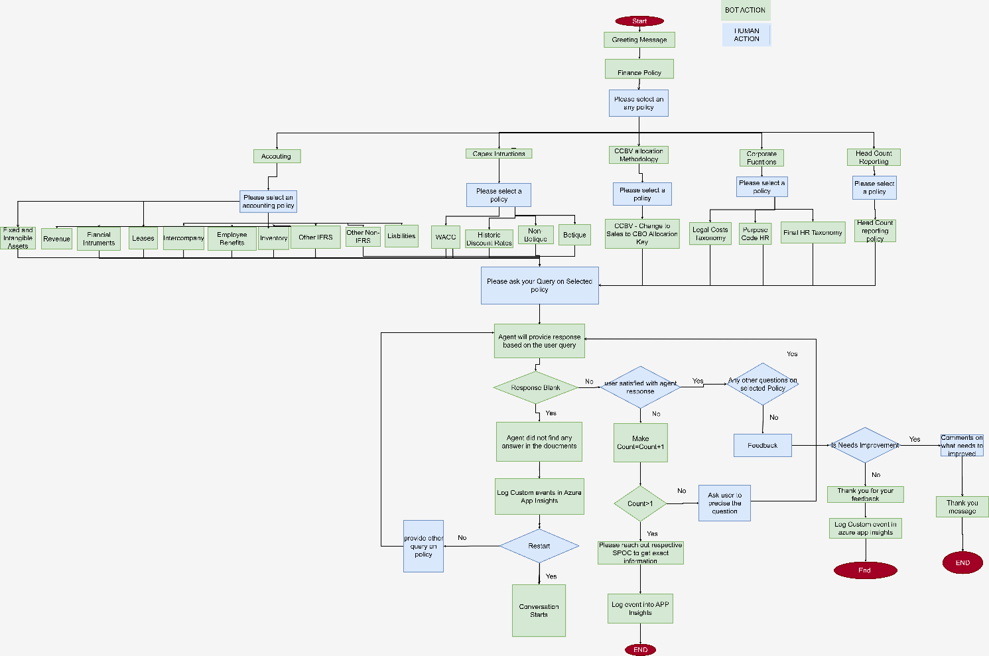

**Diagram 1.0**: Flow Diagram for Finance policies agent

Link to Diagram: [Fiance agent.drawio](https://capgemini-my.sharepoint.com/:u:/p/gumma_kumari/EWbnFMS1BmFDjVbHkRpcCY0BeiyXLrhRUurI3SUKSmeh-g?email=suranjana.chowdhury%40capgemini.com&e=QZKtRP&xsdata=%3D%3D&sdata=ZnlMa1ROK3lHcjdUTmVaWWx3QXc2NWRTVTBRZDZ1ZmlsMjc0S25XK1pXcz0%3D&ovuser=e6cbec2f-2f23-43ca-82c4-51a7c9b71e7a%2Cgumma.kumari%40chanel.com)

## 4.3 Finance policies agent Diagram Overview

The flow diagram illustrates the workflow of the Finance policies, designed to handle user queries and create log in azure app insights. Below is a step-by-step explanation of the workflow:

**1. Initial Interaction**

* 1. **Welcome Message**:
* The chatbot greets the user and presents one options:
* **Finance Policy**: For queries related to Finance
* Once Finance policy is selected, sub policies under finance policy will be show as options
* 1. **Accounting,**
* **2. Capex instructions,**
* **3. corporate functions,**
* **4. CCBV-Allocation Methodology,**
* **5. Head count reporting**

**2. Sub policies selection**

**2.**1 If user selects **Accounting**, bot will show up options for user to select an **accounting policy**

**1. Fixed and Intangible Assets**

2. **Employee Benefits**

**3. Functional instruments**

**4. Intercompany**

**5. Inventory**

**6. Leases**

**7. Revenue**

**8. CCBV**

**9. Liabilities**

**10. Other IFRS**

**11. Other Non-IFRS**

**2.2** If user selects **Capex Instructions**

**1. Botique**

**2. Non-Botique**

**3. Historic Discount Rates**

**4. WACC**

**2.3** If user selects **Corporate Functions**

**1. Legal Cost Taxonomy**

**2. Final HR Taxonomy**

**3. Purpose Code HR**

**2.4** If user selects **CCBV-Allocation Methodology**

**1. CCBV-change to sales to CBO Allocation Methodology**

**2.5** If user selects **Headcount Reporting**

**1. Headcount Reporting Policy**

**3. Policy Query Interaction Process**

**3.1 Initial Query Response**

* Step 1: After the user selects a policy, the agent will prompt the user to provide a query based on that policy.
* Step 2: The agent fetches a response based on the user’s query.
  + If no response is found:
    - The agent will display the message:  
      **"Thank you for your query. I did not find any answer from the selected policy."**
    - The agent will offer the option to restart the conversation and select the correct policy again.
    - A log entry will be created in Azure Application Insights with relevant details (such as policy selected, query, and timestamp).
    - The agent will ask: **"Do you have any other questions?"**
      * **If the user says Yes,** they will be allowed to ask another query, and the process will repeat from **Step 1.**
      * **If the user says No,** the conversation ends, and the agent proceeds to **Step 3.**

**4.2 Valid Query Response**

* **Step 3: If a response is found:**
  + The agent will ask the user**: "Are you satisfied with the answer provided?"**
    - **If the user answers Yes:**
      * The agent will ask**: "Do you have any other questions?"**
        + If the user answers **Yes,** they can ask another query, and the process will repeat from **Step 1.**
        + If the user answers **No,** the agent will ask**: "Can you please provide a more precise question for a better answer?"**
    - **If the user answers No:**
      * The agent will suggest**: "Please reach out to a SPOC for a clearer answer."**
      * A log will be created in Azure Application Insights with the following details:
        + **Policy selected**
        + **User's query**
        + **Subcategory (if applicable)**
        + **Time zone**
        + **User's feedback (if any)**
      * The agent will then ask**: "Do you have any other questions?"**
        + **If yes**, the user may ask another query, and the process repeats from **Step 1.**
        + **If no,** proceed to **Step 4.**

**3.3 Feedback Collection**

* **Step 4: If the user has no more questions, the agent will ask for feedback with the following options:**
  + 1. **Good**
    2. **Average**
    3. **Needs Improvement**
    4. If the user selects **Needs Improvement:**
       - The agent will ask the user to provide comments on what needs to be improved.
       - The comments will be logged into Azure Application Insights along with the rest of the relevant details (policy, query, subcategory, time zone, etc.).

**3.4 Log Data in Azure Application Insights**

* Every interaction (including no-response scenarios, user feedback, and the final conversation details) will be logged in Azure Application Insights, capturing:
  + **Policy selected**
  + **User's query**
  + **Subcategory**
  + **User’s time zone**
  + **Response status (whether valid or not)**
  + **User feedback (if provided)**

# 5 Solution Components

## 5.1 Create the Co-Pilot using Microsoft Co-Pilot Studio

* Initially, create the Co-Pilot by providing the Name, Icon, Description and Instructions of the Co-Pilot in Overview Tab and then click on save button.

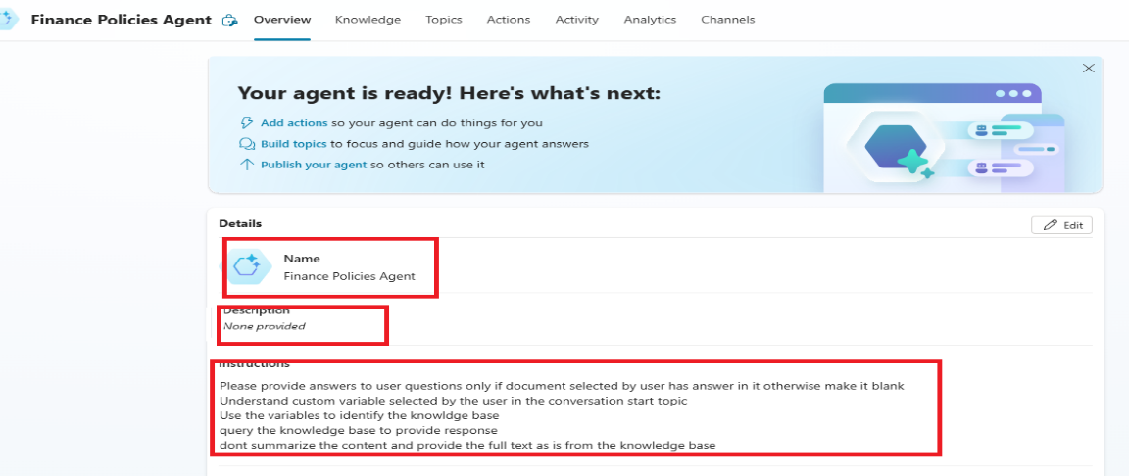

***Fig: Basic Required things for the Copilot in Microsoft Copilot Studio***

## 5.2 Train the Created Co-Pilot with the Required Data

* Once Overview is completed, Add the Knowledge in Knowledge Tab. Train the Copilot with the necessary data to ensure it provides accurate and relevant responses to user queries.
* After clicking the Add Knowledge tab, we can add knowledgebase from different sources like Public Website or SharePoint or Dataverse ...etc based on the requirement.  
  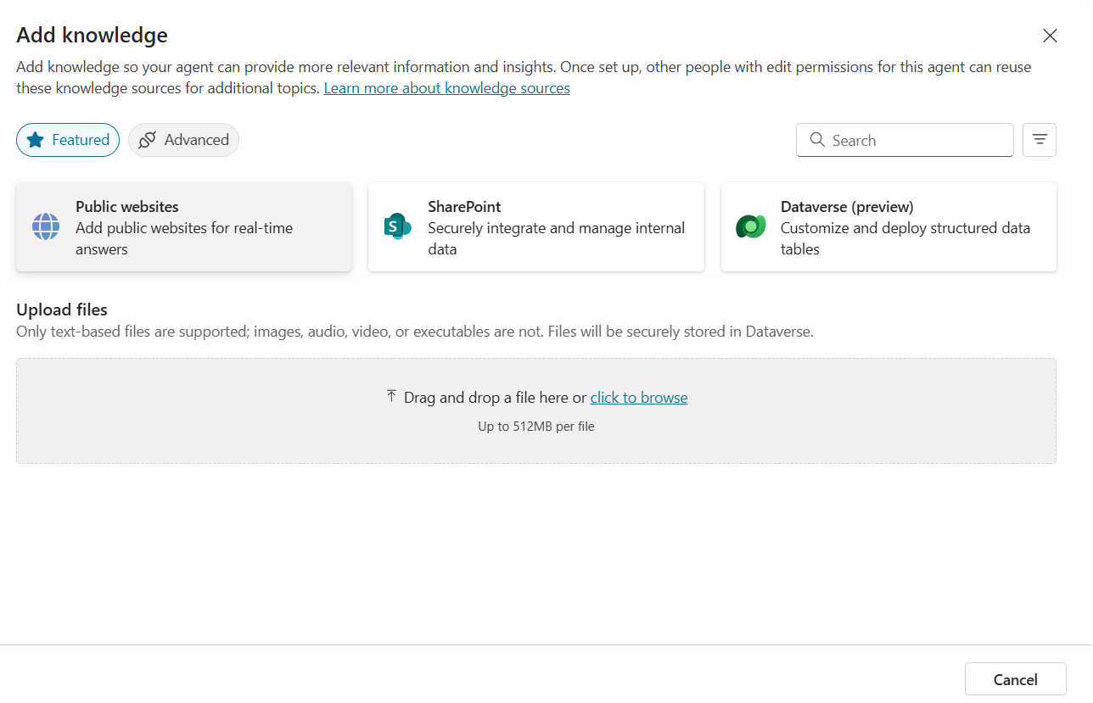

**Fig: Adding the Knowledgebases to the Chatbot**

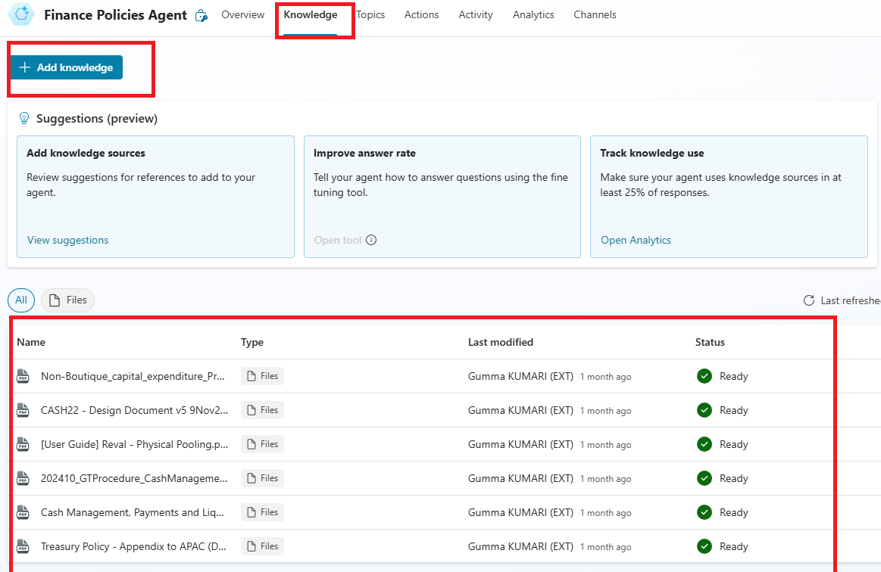

***Fig: Added some Knowledge for this Copilot***

## 5.3 Create the Topics in Co-Pilot

* After Knowledge, add the topic for the Co-Pilot. In the topics section, we have system topics and Custom topics. We can create our topics based on our requirements.

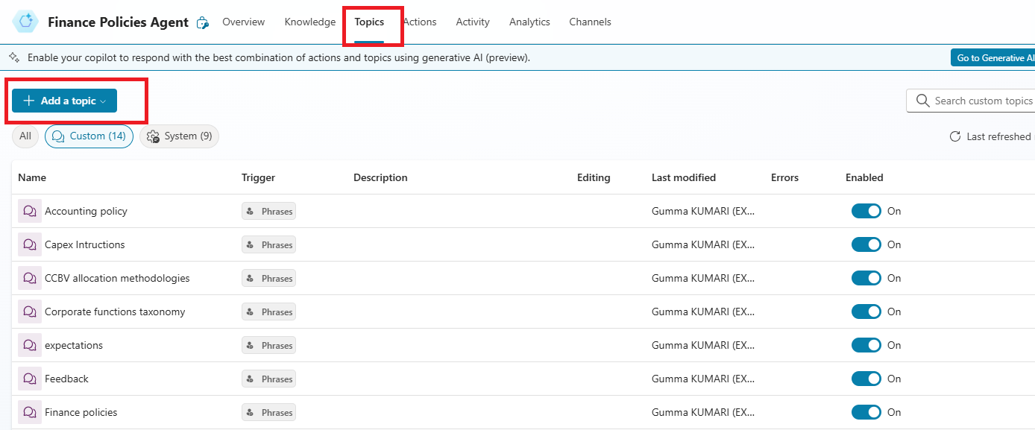

***Fig: Copilot Topics in Microsoft Copilot Studio***

***5.4* Giving Citation to user to click the get the actual document**

* We are giving the citation to users for reference to click on get the actual document from where the actual response is coming from. So that, user can check the document***.***

***Fig: Citations for User Reference***

# 6 Data

NA

# 7 Regulatory Requirements

*NA*

# 8 Security

*Only Finance team is accessing the Bot*

## 8.1 Risks and Mitigation

*<Brief overview on how the different stakeholders interact with the solution, what are the risks associated and the mitigation actions for those risks>*

## 8.2 Solution Metrics

## 8.3 License Estimation

## 8.4 Triggers

When user asks a question to the Chatbot.

## 8.5 Business

*<List all know business exceptions, per task, that are expected for the solution. Each exception should include details such as the task, exception description, affected applications and manual actions needed to solve issue either by Business or Support teams>*

## 8.6 Technical

*<List all know system exceptions, per task, that are expected for the solution. Each exception should include details such as the task, exception description, affected applications and manual actions needed to solve issue or to alert the person/team that can solve the issue>*